**Ideation Phase**

**Brainstorm & Idea Prioritization Template**

**Step-1: Team Gathering, Collaboration and Select the Problem Statement**

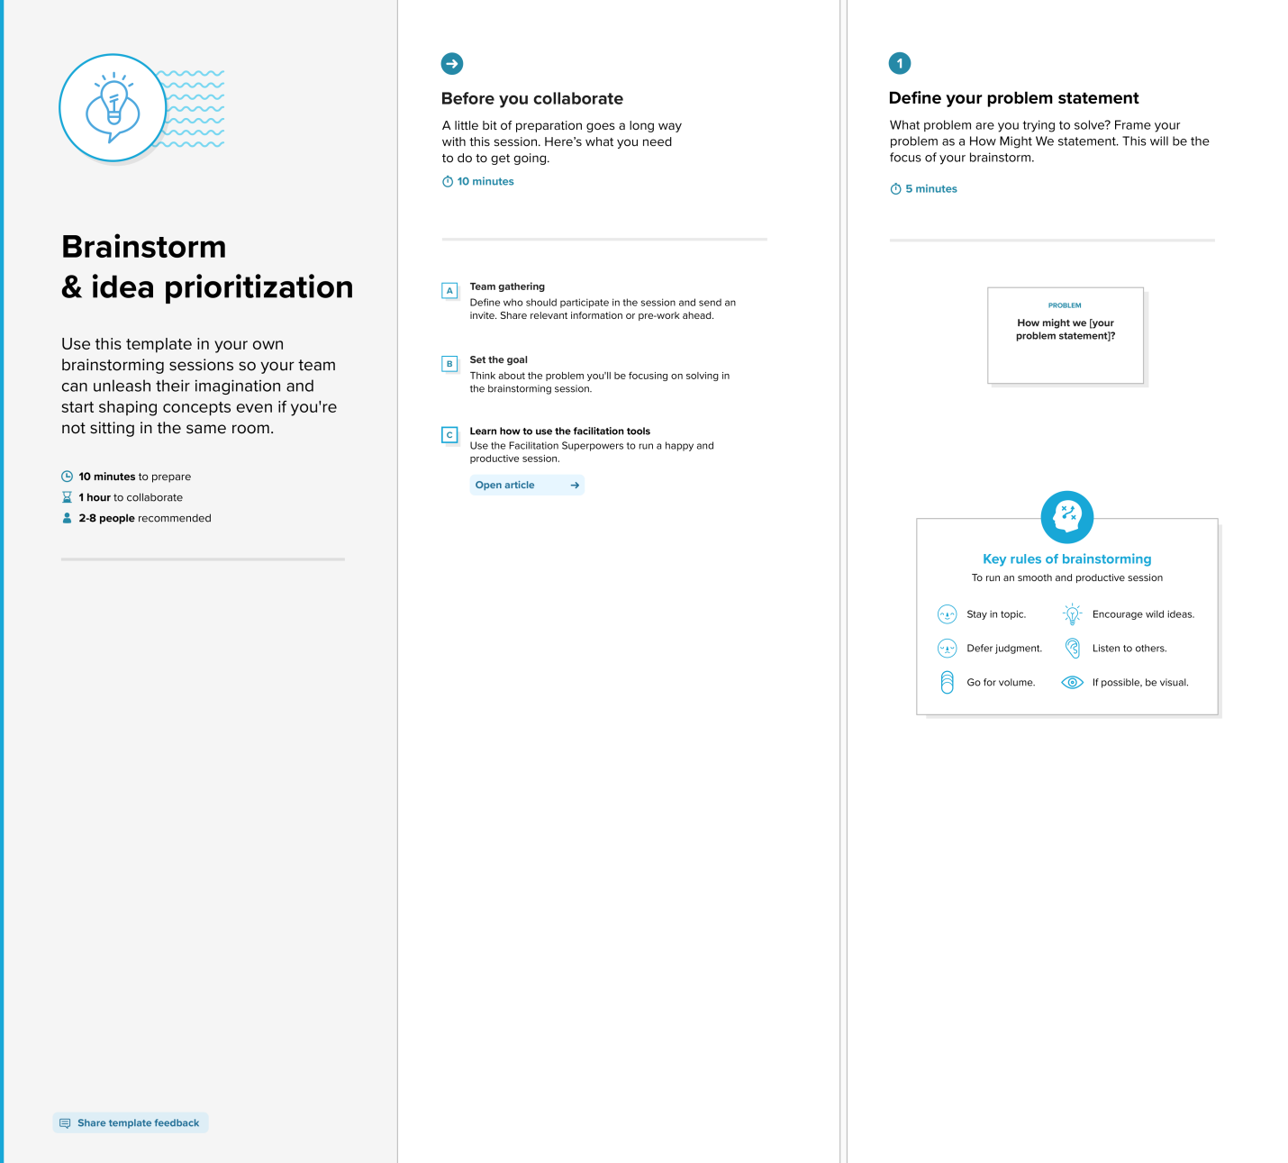

**Step-2: Brainstorm, Idea Listing and Grouping**

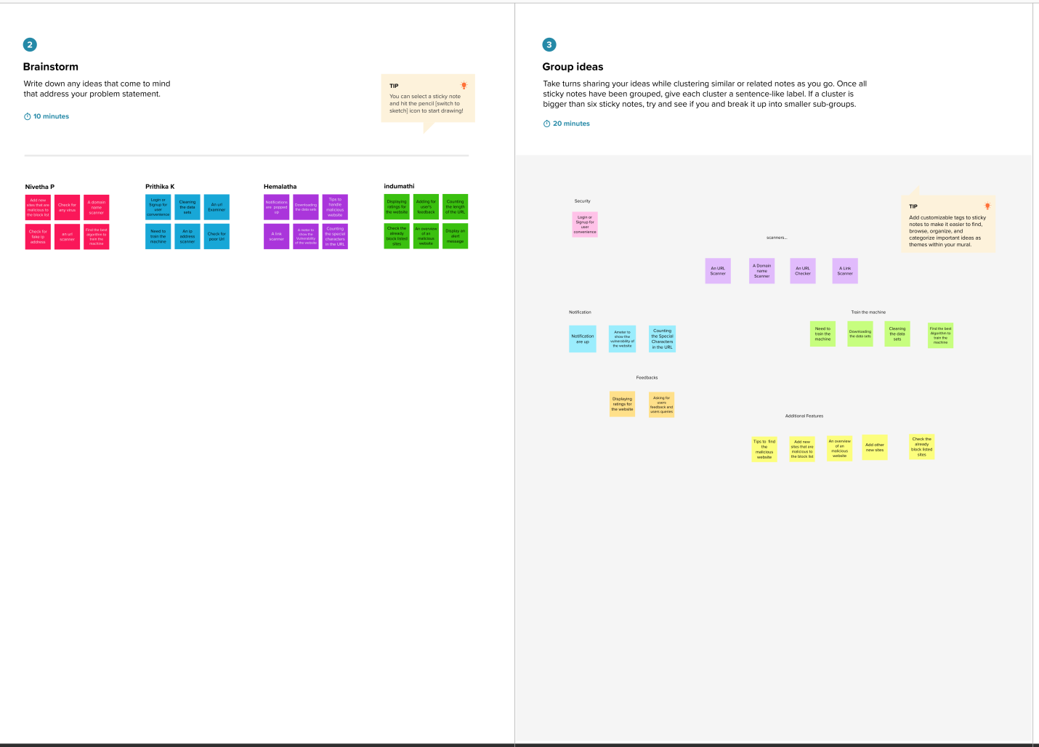

**Step-2: Brainstorm, Idea Listing and Grouping**

